Science Adventure School (SAS) is an adventure-based outdoor science school dedicated to empowering and educating West Virginia’s youth. We integrate adventure sports-driven STEM curricula with hands-on engaging environmental curriculum to inspire inquiry, instill confidence, and prepare students for their future.This report is the latest in an ongoing SAS evaluation program.

**Goal**

The goal of our yearly evaluation is to collect consistent data that allows us to assess the impact of our programming on students. Our intent is to build understanding of our outcomes and support program improvement.

**Research Design**

SAS has two primary areas of assessment:

* **STEM Attitudes** - assesses ways in which SAS encourages students to develop positives attitudes toward STEM subjects and activities
* **Positive Youth Development** - assesses ways in which SAS impacts students personally, socially and emotionally.

These two areas of assessment have been chosen to be evaluated based on our goal of preparing students for a successful future. STEM is a crucial area of work-force development that will benefit both students and their community. Just as important, STEM is a natural way to teach curiosity, wonder, and academic confidence that can consequently increase excitement in other subject areas. While SAS focuses on STEM curricula, it is with the intention of creating a path to greater academic achievement and attainment.

SAS focuses on positive youth development as a way of developing the soft skills needed for a future in the modern workforce. By teaching students communication skills, building their grit and perseverance, and providing them with a supportive community, we believe that we can prepare them for the road ahead.

In addition to these two main areas, SAS also collects statistics related to demographics, time spent outside, and comfort in the outdoors. An additional SAS goal is to support the state of WV as it explores an outdoor economy by encouraging students’ value and interest in outdoor activities.

**Methods, Data Collection, and Data Analysis**

SAS collects data from students and their teachers. All students who completed the WVU IRB consent process and attended SAS were given retrospective pre- and post- surveys to understand their change in attitudes from before and after the SAS orientation experience. Evaluation at SAS takes a census approach, meaning that all students who attend SAS have an opportunity to participate in yearly evaluation. Evaluation does not currently include a control group for two reasons: 1) many schools bring all or most of their 6th grade student meaning there is not a control group left behind and 2) in prior years we discovered that when schools do not bring all 6th graders, there is often some criteria that students must meet to attend SAS, meaning that the students left at school are not a representative control sample. In the surveys, students were asked to rate statements on a scale of 1-5. A paired sample t-test analysis was used to determine significant changes in attitudes between pre- and -post surveys.

School personnel who attend SAS were given a survey at the end of the program. This survey was primarily focused on program quality and satisfaction. After the SAS program ended, an additional survey was emailed that asked teachers and other school employees to reflect on any impacts they had observed in SAS students after their return to their school communities.

**Student Survey Results**

The following section provides the results of the pre- post- surveys given to students at SAS. SAS currently operates at four sites: the Summit Bechtel Reserve (SBR), the WVU Outdoor Education Center (OEC), Jackson’s Mill 4-H Camp, and Heritage Farm. Results are analyzed by site. SAS has a place-based curricula and our sites are geographically diverse enough that they draw on a slightly different demographic of student. Therefore, we feel it is more accurate to analyze each site separately. For brevity, this report only contains results from the SBR site as it has the largest sample of students. There is an additional full report available that contains the results from the OEC and Jackson’s Mill sites. Not enough surveys were obtained from Heritage Farm to be analyzed.

A Note on Sample Size

The sample size of analyzable surveys varies across sites. While the SBR sample is the largest of the three (n=266) and therefore more likely to be an accurate representation of the 6th grade population being studied, it is still less than an ideal size.

One of the weaknesses in the SAS evaluation plan is the relatively low number of students who are able to participate in the program and survey completion rates. This will likely lessen as the program grows. In the meantime, to strengthen evaluation efforts, the samples from 2021 through 2023 have been combined for the SBR site. This is included as an addendum to this report.

**Summit Bechtel Reserve Student Survey Results**

Demographics

Over the course of six weeks, 701 sixth grade students attended the Science Adventure School at the Summit Bechtel Reserve (SBR). Demographic questions were given as pre-written options for students to choose. Each set of questions had an "Other" option with a text box allowing students to fill their gender or racial and ethnic identity if it was not given as an option, as well as a “Do not want to provide” option.

Students were primarily Caucasian/White, with slightly more girls attending the SBR site than boys this year. The one student who wrote in a response to the “other” gender option was “genderfluid”.

Survey Results

Of the 701 SAS students at the SBR site, 406 students completed surveys. One hundred and forty surveys were eliminated due to completion issues yielding a final response rate of 66%. Therefore, 266 paired t-tests were used in the final analysis.

**Table 1: SBR Demographics**

|  |  |  |  |  |
| --- | --- | --- | --- | --- |
| **Race** |  |  | **Gender** |  |
| Caucasian | 69% |  | Female | 52% |
| African American | 9% |  | Male | 45% |
| Hispanic/Latino | 1% |  | Other | 1% |
| Asian | .5% |  | Do not want to provide | 2% |
| Native American Indian/Indigenous American | 2% |  |  |  |
| Two or more races | 6.5% |  |  |  |
| Other | 2% |  |  |  |
| Do not want to provide | 10% |  |  |  |

STEM Attitudes

At the SBR site, ***all but one STEM attitude item experienced a significant positive change***. For this analysis, “significant” means that there is a 95% likelihood that the changes from the pre- to post- survey did not occur due to random chance. There was only one item which was found to be statistically non-significant. The following table details the results of the analysis with each item grouped in the overall category being assessed. The items with the top three highest increases from pre- to post- have been bolded and italicized.

**Table 2: SBR STEM Attitude Items with Significant Positive Change from Pre- to Post- Survey**

|  |  |  |  |  |  |
| --- | --- | --- | --- | --- | --- |
|  |  | Pre Mean | Post Mean | Mean change | Sig. two tailed |
| STEM Self-Efficacy | I think I am very good at doing experiments. | 3.70 | 3.83 | +.13 | .044 |
| I can do the science activities I get in class. | 3.92 | 4.26 | +.34 | <.001 |
| ***I think I am very good at coming up with questions about science.*** | ***2.94*** | ***3.43*** | ***+.49*** | <.001 |
| STEM Interest | ***Science lessons are fun.*** | ***3.80*** | ***4.06*** | ***+.56*** | <.001 |
| I would like to learn more about science. | 3.68 | 3.89 | +.21 | .003 |
| Science is one of the most interesting school subjects. | 3.27 | 3.48 | +.21 | .002 |
| STEM Career Interest | When I leave school, I would like to work with people who make discoveries in science. | 2.92 | 3.25 | +.33 | <.001 |
| A job as a scientist would be interesting. | 3.12 | 3.34 | +.22 | .002 |
| ***I would like to be a scientist when I leave school.*** | ***2.26*** | ***2.69*** | ***+.43*** | <.001 |
| STEM Identity | I am a science person. | 2.84 | 3.12 | +.28 | <.001 |
| My family thinks of me as a “science person.” | 2.27 | 2.63 | +.36 | <.001 |
| My teachers/instructors thinks of me as a “science person.” | 2.60 | 2.86 | +.26 | <.001 |
| STEM Value | Thinking like a scientist will help me do well. | 3.56 | 3.89 | +.33 | <.001 |
| Knowing science helps me understand how the world works. | 4.05 | 4.26 | +.21 | .001 |

SBR STEM Items with No Significant Change

The only item which was found to be non-significant was “Knowing science is important.” in the STEM Value category.

Positive Youth Develop Attitudes

At the SBR site, the majority of positive youth development attitude items experienced a significant positive change, while five items did not. ***All items in the categories of Outdoor Attitudes, Grit and Perseverance, School Belongingness, and Social Self-Efficacy experienced a significant increase***. The items with the top three highest increases have been bolded and italicized. A table with non-significant items is included with corresponding categories.

**Table 3: SBR Youth Dev. Attitude Items with Significant Positive Change from Pre- to Post- Survey**

|  |  |  |  |  |  |
| --- | --- | --- | --- | --- | --- |
|  |  | Pre Mean | Post Mean | Mean change | Sig. two tailed |
| Outdoor Attitudes | I like being in nature. | 4.30 | 4.45 | +.15 | .011 |
| I want to spend time outdoors. | 4.24 | 4.45 | +.21 | <.001 |
| ***I feel connected to the natural environment.*** | ***3.74*** | ***4.11*** | ***+.40*** | ***<.001*** |
| Environmental Attitudes | Humans are part of nature, not separate from it. | 3.91 | 4.16 | +.25 | <.001 |
| I have the power to protect the environment. | 4.05 | 4.24 | +.19 | .002 |
| Grit and Perseverance | ***I have overcome setbacks to conquer an important challenge.*** | ***3.84*** | ***4.14*** | ***+.30*** | ***<.001*** |
| I am a hard worker. | 4.12 | 4.31 | +. 19 | <.001 |
| Setbacks don’t discourage me. | 3.74 | 3.98 | +.24 | <.001 |
| I have achieved a goal that took time to reach. | 4.21 | 4.44 | +.23 | <.001 |
| School Belongingness | I feel like a part of my school. | 3.81 | 4.06 | +.25 | <.001 |
| Other students here like me the way I am. | 3.91 | 4.04 | +.13 | .023 |
| There’s at least one teacher or other adult in this school I can talk to if I have a problem. | 4.11 | 4.24 | +.13 | .031 |
| WV Attitudes | I feel good about my West Virginia background. | 4.23 | 4.36 | +.13 | .015 |
| I like people to know that I am from West Virginia. | 4.11 | 4.25 | +.14 | .004 |
| Teamwork | I am very cooperative when I work in groups. | 3.98 | 4.12 | +.14 | .010 |
| Social Self-Efficacy | How well can you become friends with other children? | 3.90 | 4.10 | +.20 | <.001 |
| How well can you tell other children that they are doing something that you don’t like? | 3.36 | 3.65 | +.29 | <.001 |
| ***How well can you express your opinions when other classmates disagree with you?*** | ***3.46*** | ***3.82*** | ***+.36*** | ***<.001*** |

**Table 4: SBR Positive Youth Development Items with No Significant Change**

|  |  |
| --- | --- |
| Teamwork | I respect the opinions of my teammates, even when I disagree. |
| I listen carefully to other group members when our team is making a decision. |
| WV Attitudes | I have a lot of pride in being from West Virginia. |
| Environmental Attitudes | I feel it is important to take good care of the environment. |
| Social Self-Efficacy | How well do you succeed in staying friends with other children? |

Additional Statistics

SAS also collects statistics on safety in nature, time outside, likelihood of taking STEM classes, likelihood of pursuing a STEM job, and desire to make a change after SAS. These questions were analyzed through a frequency count.

Safety in Nature

This question assesses how safe students feel in nature pre- vs. post- SAS. Feelings of safety increased post- SAS. Notably, 28% of students selected the highest level of safety in the pre- survey, which ***increased to 70% of students at the highest level of safety*** by the post- survey.

**Table 5: SBR Safety in Nature**

|  |  |  |  |  |
| --- | --- | --- | --- | --- |
| On a scale of 1-5, how safe did you feel being in nature **BEFORE** SAS, with 5 as the safest? | |  | On a scale of 1-5, how safe did you feel being in nature **AFTER** SAS, with 5 as the safest? | |
| 1 | 5% |  | 1 | 1% |
| 2 | 8% |  | 2 | 2% |
| 3 | 28% |  | 3 | 5% |
| 4 | 31% |  | 4 | 22% |
| 5 | 28% |  | 5 | 70% |

Time Outside

This question asked students to rank how much time they currently spend outside and how much time they would like to spend outside after SAS. While many students may not be able to control their ability to spend time outside, this question still gives a good indication of changes in how students value spending time outside as opposed to pursuing indoor activities in their free time. In general, students believed that they will spend much more time outside after SAS, ***with a 19% increase in the number of students who want to spend 4 or more hours outside.***

**Table 6: SBR Time Outside**

|  |  |  |  |  |
| --- | --- | --- | --- | --- |
| How much time did you spend outside every day **BEFORE** coming to SAS? | |  | How much time do you think you will spend outside every day **AFTER** coming to SAS? | |
| None | 3% |  | None | 2% |
| < 30 minutes | 12% |  | < 30 minutes | 3% |
| About 30 mins | 15% |  | About 30 mins | 11% |
| About 1 hour | 22% |  | About 1 hour | 20% |
| 2-3 hours | 32% |  | 2-3 hours | 29% |
| 4+ hours | 16% |  | 4+ hours | 35% |

Classes and STEM Jobs after SAS

These questions assess students’ regard toward continuing to learn STEM after SAS and their thoughts on the possibility of pursuing STEM jobs in the future. After SAS, ***students were more likely than less likely to want to take elective STEM classes***. Interestingly, ***there was little difference in the “less likely” and “more likely” category for likelihood of having a STEM job***. Research in 2024 will include a focus on gaining a greater understanding of this question’s results, particularly as the student survey results show increases in attitudes surrounding STEM Career Interest.

**Table 7: SBR Future STEM Participation**

|  |  |  |  |  |
| --- | --- | --- | --- | --- |
| How likely are you to take STEM classes if you don’t have to, **AFTER** Adventure School? | |  | How likely are you to want to have a STEM job **AFTER** Adventure School? | |
| Less likely | 9% |  | Less likely | 23% |
| About the same | 52% |  | About the same | 52% |
| More likely | 38% |  | More likely | 25% |
| Did not provide | 1% |  |  |  |

Doing Something Different After SAS

The final demographic question assesses whether students feel like they will do something different after their SAS experiences. The majority of students did feel that they would do something differently.

**Table 8: SBR Life Change**

|  |  |
| --- | --- |
| After participating in SAS, do you intend to do anything differently in your life? | |
| Yes | 64% |
| No | 36% |

Qualitative Data

In the above question, students were also asked to provide details of what they would change. Of the 169 students who answered “Yes”, 161 provided additional details about what that change would be. Their responses are summarized in a table below. Note that the total percentage adds up to more than 100%, as some students reported they would make changes in multiple categories.

**Table 9: SBR Students’ Desired Change**

|  |  |  |
| --- | --- | --- |
| Theme | Representative Statement | Percent Mention |
| Spend More Time Outside/Being Active | “I will be outdoors much, much more and explore nature more.” | 26% |
| Do More of an Outdoor Activity Learned at SAS. | “Camping, now I know that it is not that bad to sleep outside.” | 17% |
| Take Care of Nature/Environment | “Do good things and pick up trash so it doesn't end up in the woods for the squirrels to eat.” | 30% |
| Indication of Social/Emotional Growth | “I will try to have more of a positive attitude and believe in myself more often.” | 9% |
| Future Job | “I would become a teacher or nurse, or a SAS guide.” | 6% |
| Science | “Yes, because SAS has taught me to like and love science. “ | 11% |
| Join Similar Organizations | “I would like to do 4-H more.” | 4% |
| Didn’t Know Yet | “I don’t know.” | 5% |
| Other | “I really want to make more crafts.” | 6% |

Overall, most students reported that they spend more time outdoors and/or being active and would do more to respect nature and protect the environment in the future. Some also planned to engage in more of the activities they participated in during SAS including recreational activities like archery, biking, and camping, and more nature-based activities like looking for salamanders and using reflective techniques learned during the SAS nature bathing activity. A smaller percentage of students indicated changes that included interest in engaging in more science-based activities, thoughts on future careers, behavior changes related to social/emotional growth, or the desire to join 4-H or the Boy Scouts of America as a way of participating in similar outdoor youth programming in the future.

**Teacher Results**

Post SAS Experience Survey

At the end of SAS, teachers are given a survey to share their thoughts on the SAS experience. The survey is designed to gauge program satisfaction and gives valuable insight on the school perspective. Of the ninety-one teachers who attended SAS, sixty-five completed surveys.

Teachers were asked to reflect on the performance of SAS seasonal staff. SAS Outdoor Education guides are with students for their entire SAS experience and are responsible for managing group dynamics and delivering positive youth development curriculum. Environmental Education instructors and STEM instructors are responsible for delivering environmental science curricula and STEM curricula. ***Survey respondents were extremely satisfied with the quality of SAS instructors.***

**Table 28: Teacher Satisfaction with SAS Staff Performance**

|  |  |  |  |  |  |  |  |
| --- | --- | --- | --- | --- | --- | --- | --- |
| I would describe my group’s **OE guides** as… | |  | I would describe my group’s **Environmental Education instructors** as… | |  | I would describe my group’s **STEM instructors** as… | |
| Excellent | 97% |  | Excellent | 100% |  | Excellent | 98% |
| Good | 1.5% |  | Good | 0% |  | Good | 2% |
| Satisfactory | 1.5% |  | Satisfactory | 0% |  | Satisfactory | 0% |
| Fair | 0% |  | Fair | 0% |  | Fair | 0% |

Teachers and school staff were asked “Do you feel your students’ emotional and physical safety needs were met?” and ***100% answered “Yes”.*** Additionally, they were asked to give SAS a letter grade (A-F) and ***100% of survey respondents gave the SAS program an “A”.***

Student Impact Survey

Teachers and school personnel who attended SAS were sent an additional survey via email after the last week of SAS programming. This survey focused on observed program impacts in their schools after the SAS experience. While the amount of time back at school after SAS varied, all school staff would have had a week at minimum of time to interact with students after SAS. The majority of respondents had a month or more with students after SAS. Survey recipients were also told that they could forward the survey to colleagues who might not have attended SAS but were in a position to observe changes pre- to post- SAS experience. Thirty-three teachers or other school personnel responded to the impact survey.

Overall, teachers felt ***that the SAS experience was substantially valuable for students***. Respondents reported that after attending SAS, they noticed positive classroom impacts, particularly in classroom engagement. They also ***reported a positive impact on students needing additional behavioral or academic support***. Additionally, teachers were asked to reflect on a portion of the categories included in the student survey to add an additional data source for potential positive changes. In general, ***most respondents reported moderate or substantial positive change.***

**Figure 1: How Valuable Was the SAS Experience?**

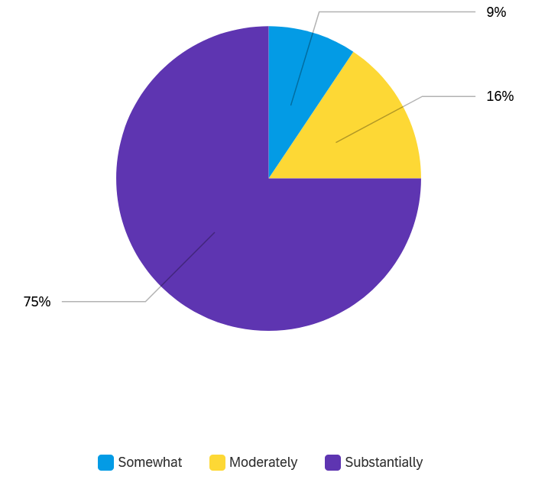

**Figure 2: SAS Classroom Impacts**

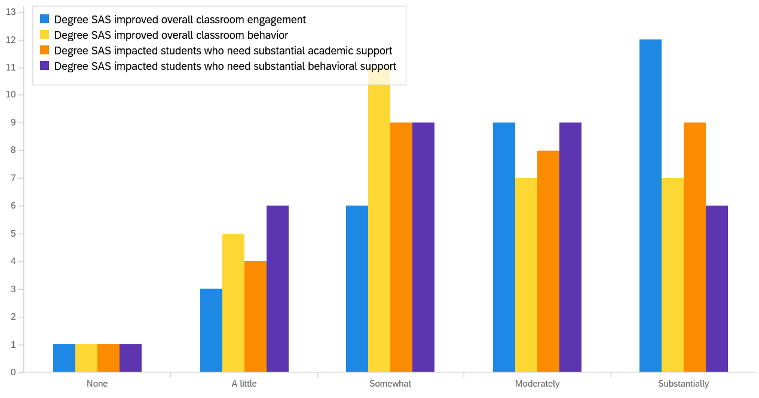

**Figure 3: Specific Student Impacts**

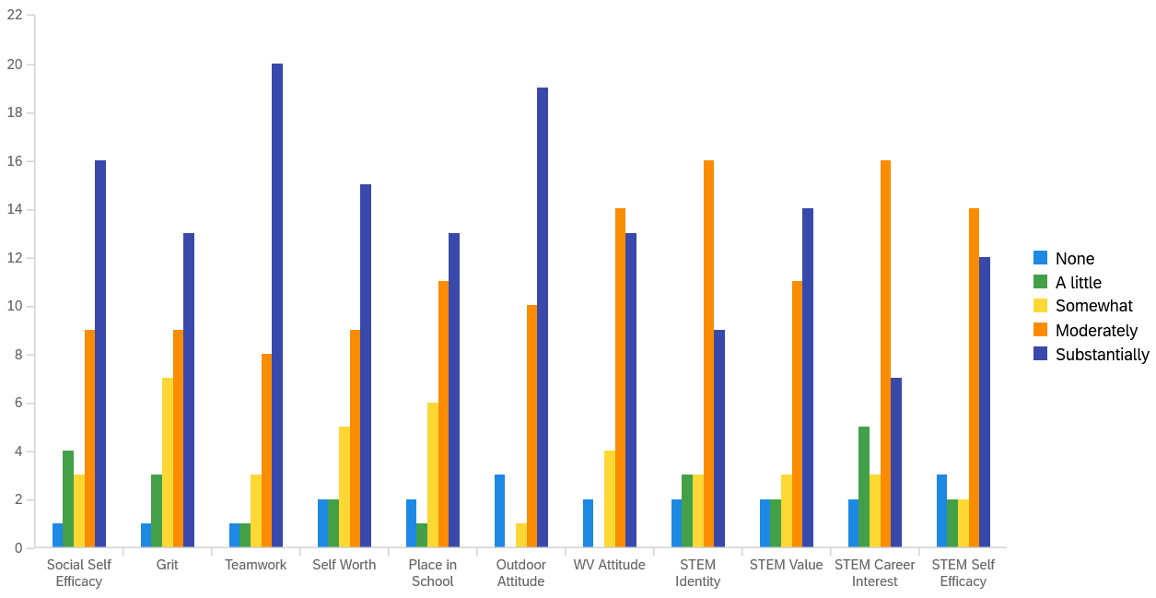

**Conclusion**

While additional discussion and conclusions of the 2023 SAS results will continue to be added to this preliminary report, at this point, data from both teachers and students provides support for the value of Science Adventure School to the students of West Virginia as an intervention that shows evidence of increasing social, emotional, and social skills, and increasing positive attitudes toward STEM.

For now, this report concludes with a quote from a teacher who completed the impact survey and chose to share additional thoughts:

*“I have seen students work together from various backgrounds that would never have socialized prior to this experience. Students bonded and became more accepting of others' differences and their own. They developed critical thinking skills through hands-on, FUN activities that pushed their boundaries mentally and physically. They bonded over shared experiences, developed friendships, and also matured in a way that is hard to put into words. SAS was a wonderful experience that I would love to see more students be able to experience.”*

**Summit Bechtel Reserve Survey Data from 2021-2023**

These tables are meant to be an addendum to the 2023 SAS research report. The goal of this data is to show greater generalizability of SAS results through use of a larger sample size of students. This dataset is a combination of data collected at the Summit Bechtel Reserve from the years 2021-2023. Before combining, the demographics and school attendance of each year was examined to ensure that they were similar. After datasets were combined, they were analyzed in the same manner as the individual sets, with frequency analysis used for demographic statistics and a paired sample t-test for the pre-post- student impacts. The combined sample size for the SBR site was 634 students.

**Demographic Questions: Race and Gender**

|  |  |  |  |  |
| --- | --- | --- | --- | --- |
| **Race** |  |  | **Gender** |  |
| Caucasian | 69% |  | Female | 50% |
| African American | 6% |  | Male | 46% |
| Hispanic/Latino | 1% |  | Other | 2% |
| Asian | 1% |  | Do not want to provide | 2% |
| Native American Indian/Indigenous American | 2% |  |  |  |
| Two or more races | 6% |  |  |  |
| Other | 4% |  |  |  |
| Do not want to provide | 11% |  |  |  |

SBR Student Survey Results

At the SBR site, ***all but two Positive Youth Development attitude items*** ***experienced a significant positive change***. There were only two items which were found to be statistically non-significant. The following table details the results of the analysis with each item grouped in the overall category being assessed. The items with the top three highest increases for STEM and Youth Development have been bolded and italicized. Additionally, the STEM items have been colored coded blue and the Youth Development items have been coded green.

|  |  |  |  |  |
| --- | --- | --- | --- | --- |
|  |  | Pre Mean | Post Mean | Mean change |
| STEM Self-Efficacy | I think I am very good at doing experiments. | 3.64 | 3.83 | +.19 |
| I can do the science activities I get in class. | 3.94 | 4.22 | +.28 |
| ***I think I am very good at coming up with questions about science.*** | ***2.92*** | ***3.37*** | ***+.45*** |
| STEM Interest | Science lessons are fun. | 3.91 | 4.08 | +.17 |
| I would like to learn more about science. | 3.76 | 3.93 | +.17 |
| Science is one of the most interesting school subjects. | 3.50 | 3.65 | +.15 |
| STEM Career Interest | When I leave school, I would like to work with people who make discoveries in science. | 3.02 | 3.30 | +.28 |
| A job as a scientist would be interesting. | 3.36 | 3.51 | +.15 |
| ***I would like to be a scientist when I leave school.*** | ***2.34*** | ***2.71*** | ***+.37*** |
| STEM Identity | I am a science person. | 2.99 | 3.19 | +.20 |
| ***My family thinks of me as a “science person.”*** | ***2.19*** | ***2.59*** | ***+.40*** |
| My teachers/instructors thinks of me as a “science person.” | 2.61 | 2.89 | +.28 |
| STEM Value | Knowing science is important. | 4.40 | 4.49 | +.09 |
| Knowing science helps me understand how the world works. | 4.09 | 4.29 | +.20 |
| Thinking like a scientist will help me do well. | 3.60 | 3.93 | +.33 |
| Positive Outdoor Attitudes | I like being in nature. | 4.23 | 4.41 | +.18 |
| I want to spend time outdoors. | 4.15 | 4.36 | +.21 |
| ***I feel connected to the natural environment.*** | ***3.76*** | ***4.11*** | ***+.35*** |
| Positive Environmental Attitudes | Humans are part of nature, not separate from it. | 3.96 | 4.21 | +.25 |
| I have the power to protect the environment. | 4.08 | 4.29 | +.21 |
| Grit and Perseverance | ***I have overcome setbacks to conquer an important challenge.*** | ***3.78*** | ***4.10*** | ***+.32*** |
| I have achieved a goal that took time to reach. | 4.17 | 4.38 | +.21 |
| I am a hard worker. | 4.05 | 4.27 | +.22 |
| Setbacks don’t discourage me. | 3.63 | 3.93 | +.30 |
| Positive WV Attitudes | I have a lot of pride in being from West Virginia. | 4.27 | 4.35 | +.08 |
| I feel good about my West Virginia background. | 4.23 | 4.32 | +.09 |
| I like people to know that I am from West Virginia. | 3.99 | 4.22 | +.23 |
| School Belongingness | I feel like a part of my school. | 3.81 | 4.03 | +.22 |
| Other students here like me the way I am. | 3.82 | 3.96 | +.14 |
| Teamwork | I respect the opinions of my teammates, even when I disagree. | 4.23 | 4.32 | +.09 |
| I am very cooperative when I work in groups. | 3.94 | 4.17 | +.23 |
| I listen carefully to other group members when our team is making a decision. | 4.23 | 4.35 | +.12 |
| Social Self-Efficacy | How well can you become friends with other children? | 3.83 | 4.05 | +.22 |
| How well can you tell other children that they are doing something that you don’t like? | 3.37 | 3.68 | +.31 |
| ***How well can you express your opinions when other classmates disagree with you?*** | ***3.41*** | ***3.74*** | ***+.33*** |
| How well do you succeed in staying friends with other children? | 4.23 | 4.37 | +.14 |

The two items which experienced no significant change were: “There’s at least one teacher or other adult in this school I can talk to if I have a problem” in School Belongingness and “I feel it is important to take good care of the environment” in the Positive Environmental Attitudes.

Additional Statistics

**Safety in Nature**

|  |  |  |  |  |
| --- | --- | --- | --- | --- |
| On a scale of 1-5, how safe did you feel being in nature **BEFORE** SAS, with 5 as the safest? | |  | On a scale of 1-5, how safe did you feel being in nature **AFTER** SAS, with 5 as the safest? | |
| 1 | 4% |  | 1 | 1% |
| 2 | 10% |  | 2 | 2% |
| 3 | 30% |  | 3 | 4% |
| 4 | 31% |  | 4 | 26% |
| 5 | 25% |  | 5 | 67% |

**Time Outside**

|  |  |  |  |  |
| --- | --- | --- | --- | --- |
| How much time did you spend outside every day **BEFORE** coming to SAS? | |  | How much time do you think you will spend outside every day **AFTER** coming to SAS? | |
| None | 3% |  | None | 2% |
| < 30 minutes | 12% |  | < 30 minutes | 4% |
| About 30 mins | 16% |  | About 30 mins | 10% |
| About 1 hour | 23% |  | About 1 hour | 21% |
| 2-3 hours | 27% |  | 2-3 hours | 29% |
| 4+ hours | 19% |  | 4+ hours | 34% |

**Classes and STEM Jobs after SAS**

|  |  |  |  |  |
| --- | --- | --- | --- | --- |
| How likely are you to take STEM classes if you don’t have to, **AFTER** Adventure School? | |  | How likely are you to want to have a STEM job **AFTER** Adventure School? | |
| Less likely | 11% |  | Less likely | 24% |
| About the same | 51% |  | About the same | 52% |
| More likely | 38% |  | More likely | 24% |

**Doing something different after SAS**

|  |  |
| --- | --- |
| After participating in SAS, do you intend to do anything differently in your life? | |
| Yes | 66% |
| No | 34% |